are left?





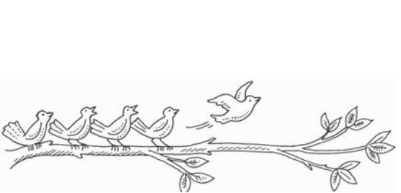

Name

**Chapter Test, Form 2A**

**Circle the correct answer.**

**45**

**Grade 1 • Chapter 2** Subtraction Concepts

**1.** There are 5 birds. 1 flies

away. How many birds

**A.** 7

**B.** 6

**C.** 5

**D.** 4

**2.** There are 6 flowers.

There are 4 bees. How many more flowers are there than bees?



**F.** 4 – 3 = 1 more flower

**G.** 8 – 7 = 1more flower

**H.** 6 – 4 = 2 more flowers

**I.** 10 – 6 = 4 more flowers

**3.** Look at the addition number sentence below. Which of the following

show a related   
subtraction fact?

5 + 3 = 8

**A.** 8 – 1 = 7

**B.** 5 – 3 = 2

**C.** 8 – 4 = 4

**D.** 8 – 3 = 5

**4.** What is the difference?

**F.** 1

**G.** 3

**H.** 7

**I.** 9

**Part**

**Part**

**1**

**Whole**

**8**

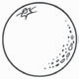

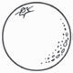

















Name

**Chapter Test, Form 2A**

*(continued)*

**Read each question. Write the answer.**

**46**

**Grade 1 • Chapter 2** Subtraction Concepts

**5.** 7

– 5

**6.** 9

– 9

**7.** Write the subtraction number sentence that goes with the picture.

**8.** Write the subtraction number sentence that goes with the picture.