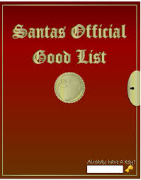
YOU DID IT!
Dear Mrs. Nelson’s 1st Graders,

Thank you for letting me be a part of your class. You have been so much fun to hang out with. Sorry for some of the messes I made. Sadly, this is my last day to be in your class. When you get back to school I will be gone, but, I will have left a gift for you.

Tonight when you are asleep, a little Christmas magic is going to happen. I will make my last report to Santa before he gets on his sleigh and heads around the world to spread Christmas cheer. When you wake up tomorrow morning I will be gone and presents will be under your tree. I know there will be presents because I told Santa all about what good boys and girls you are.

Merry Christmas Mrs. Nelson’s Class! I LOVE you! See you next year!
Oliver
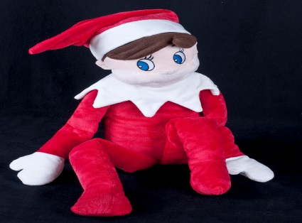
Magic Elf to Mrs. Nelson’s 1st Grade
Christmas Eve, 2014

