Math Facts Activities

Required (Mon-Fri):

You are required to practice math facts regularly at home to increase your fluency. As part of your math homework, fluency timings will be sent home each week. With the fluency timing in the plastic sheet protector, use a dry-erase marker to practice repeatedly. Record your best time and score each day on your homework form. [The end-of-the-week goal is to finish all 25 problems in 1 minute and 15 seconds, with 90% accuracy (23 out of 25 problems correct).]
Suggestions For Extra Practice:

1) FRONT ROW ED: go to https://student.frontrowed.com/#login and login with your first name, last name, and class code: urjx8h. Choose “Practice”, then “Math Fluency” (this is a good alternative to XtraMath for students who do not like to be timed during fact practice). For extra practice in other math skills, choose “Foundational Math”. Use the following calendar for a domain guide:
- September-November: Counting and Operations
- December-Mid February: Base 10
- Mid February-March: Measurement and Data
- April-May: Geometry and Fractions

2) REFLEX MATH: Practice your fact families with online games. https://www.reflexmath.com/

3) XTRA MATH: Practice math facts during one session of Xtra Math. https://xtramath.org/

**A parent flyer (included in the blue homework folder) has easy login instructions for
XtraMath on your home computer or mobile device **

4) FLASH MATH: Use a set of flash cards with ADDITION or SUBTRACTION facts. 1st graders need to demonstrate fluency for addition and subtraction within 10. You can often find flash cards at dollar stores, create them on index cards, or even create them at this site: http://www.kitzkikz.com/flashcards/

5) MATH MAGICIAN: Practice ADDITION or SUBTRACTION.
http://www.oswego.org/ocsd-web/games/mathmagician/cathymath.html

6) FAMILY MATH: Write each of the number families for the number 10. Include addition and subtraction facts for each family. For instance, for the 4-6-10 family, you should write: 4+6=10, 6+4=10, 10-6=4, and 10-4=6. The math families for 10 are: 1-9-10, 2-8-10, 3-7-10, 4-6,10, and 5-5-10. Below is a pictorial example of the 4-6-10 family, with 10 being the sum, and 4 & 6 being the addends.
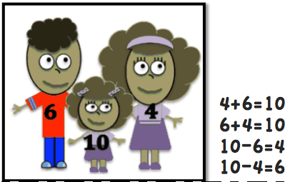

7) MATH ATTACK: Write your ADDITION facts (ALL facts up to 12). You do not need to repeat facts as you move up the number list, for example you do not need to write 3+1=4 if you already wrote 1+3=4. You may use manipulatives (such as small candies, beans, pennies, etc.) to help you calculate the correct answers.

8) MATH REVIEW: Choose any 2-digit number less than 100 and write the numbers that are one more, one less, 10 more, and 10 less than that number. Do this for 6 different numbers and write them. Here’s an example for the number 47:

47
one more: 48
one less: 46
10 more: 57
10 less: 37

9) Tug of War: You will need 2 Players, 2 Dice (or Number Cards like UNO), a piece of paper, and a small object for a game piece.
Draw a simple game board on a piece of paper (see below). Place the game piece on “start”. One player is trying to reach the 4 on the right side of “start” and the other player’s objective is to reach the 4 on the left side of “start”. Before playing, decide if you want to add or subtract, and decide if the winning roll is the highest or lowest sum (or difference). Players take turns rolling the die and adding (or subtracting) the numbers rolled. Whoever gets the highest (or lowest) sum (or difference), moves the marker in their designated direction. The marker will go back and forth until one of the players reach their 4 and is announced WINNER!

