Quest Academy Read-A-Thon!
Sponsored By:
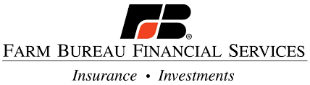
Chelsea Bonney 385-393-2745 Tyler Erickson
www.Chelsea Bonney.com www.TylerErickson.fbfs.com

We are pleased to announce that we have teamed up with Quest Academy to run Dr. Seuss Week and Spirit Week!! We will be giving away a free bicycle and helmet to the highest reader in grades K-5 and a free iPad mini to the highest reader in grades 6-9!

By signing this form, I am giving my child permission to participate in the Quest Academy Read-A-Thon. I understand that if my child is in K-5, they will be eligible to win a free bike and helmet. If my child is in 6-9, they will be eligible to win a free iPad mini.

CHILD’S NAME: _______________________________ PARENT’S NAME: _______________________________
SCHOOL GRADE: ______________________________ PHONE NUMBER: ______________________________
Yes! I’d like to set up a college savings plan.
No, I love my current plan.
Parent Signature: ________________________________________________ Date: ___________________________

