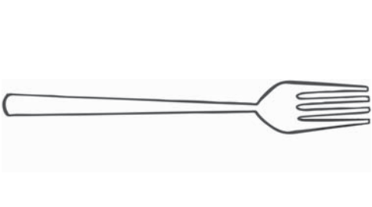

Name Date

**Chapter Test, Form 1A**

**Read each question carefully. Write the letter for your answer on the**

**line provided.**

**1.**

Estimate the length of the pencil.

**A.** 4 inches

**B.** 12 inches

**C.** 4 feet

**D.** 4 yards

**1.**

**2.**

Use a ruler to measure the fork.

**F. $1\frac{1}{2}$**  inches

**H. $2\frac{1}{2}$**  inches

**G.** 2 inches

**I.** 4 inches

**2.**

**3.**

Which is the best estimate for the weight of a bus?

**A.** 3 ounces

**B.** 3 pounds

**C.** 300 pounds

**D.** 3 tons

**3.**

**Find each unknown.**

**4.**

3 yd =

**F.** 3

ft

**G.** 6

**H.** 8

**I.** 9

**4.**

**5.**

6 qt =

**A.** 3

pt

**B.** 6

**C.** 12

**D.** 24

**5.**

**6.**

8 pt =

**F.** 4

c

**G.** 8

**H.** 16

**I.** 32

**6.**

**7.**

5 lb =

**A.** 100

oz

**B.** 80

**C.** 50

**D.** 40

**7.**

**8.**

4 T =

lb

**F.** 8,000

**G.** 4,000

**H.** 800

**I.** 400

**8.**

**9.**

How many days are in 6 weeks?

**A.** 7

**B.** 30

**C.** 42

**D.** 60

**9.**

**271**

**Grade 4 • Chapter 11** Customary Measurement

Name Date

**Chapter Test, Form 1A**

*(continued)*

**10.**

Convert 5 gallons to quarts.

**F.** 10 qt

**G.** 15 qt

**H.** 20 qt

**I.** 25 qt

**10.**

**11.**

Sandy read for 3 hours. How many minutes did she read?

**A.** 180 min

**B.** 210 min

**C.** 300 min

**D.** 330 min

**11.**

**12.**

Zaria filled 8 cups with water. How many fluid ounces did she use?

**F.** 8 fl oz

**G.** 16 fl oz

**H.** 32 fl oz

**I.** 64 fl oz

**12.**

**13.**

Telly’s cat weighs 7 pounds. Jill’s kitten weighs 3 pounds.

How many ounces do the pets weigh together?

**A.** 120 oz

**B.** 160 oz

**C.** 16 oz

**D.** 10 oz

**13.**

**For Exercises 14 and 15, use the line plot below.**

X

X X

X

X X

X

X X

X

X

X

$\frac{1}{12}$

$\frac{2}{12}$

$\frac{3}{12}$

$\frac{4}{12}$

$\frac{5}{12}$

$\frac{6}{12}$

$\frac{7}{12}$

$\frac{8}{12}$

$\frac{9}{12}$

$\frac{10}{12}$

$\frac{11}{12}$

**14.** What is the difference between the longest and shortest pencils?

**F. $\frac{3}{12}$**  ft

**G. $\frac{4}{12}$**  ft

**H. $\frac{5}{12}$**  ft

**I. $\frac{8}{12}$**  ft

**14.**

**15.** If the pencils that are $\frac{3}{12}$ of a foot long are laid end to end touching, how far would the row extend?

**A. $\frac{3}{12}$**  ft

**B. $\frac{6}{12}$**  ft

**C. $\frac{8}{12}$**  ft

**D. $\frac{9}{12}$**  ft

**15.**

**16.** Mrs. Strom is setting up two rest stops for a bike race. There are

18 gallons of water total at the two stops. The second stop has twice as many gallons as the first stop. How many gallons of water are at each rest stop?

**F.** first: 5 gal; second: 10 gal

**G.** first: 6 gal; second: 10 gal

**H.** first: 6; second: 12 gal

**I.** first: 7; second: 11 gal

**16.**

**272**

**Grade 4 • Chapter 11** Customary Measurement

**Length of Pencils (feet)**

X X X X

X X X X X

0 1