Mrs. Fisher’s 1st Grade Supply List 2015-2016
- 2 reams of copy papers
- 1 binder (2 inch 3-ring) labeled and decorated with your child’s favorite pictures and crafts

- 3 primary Journal K-2 by Mead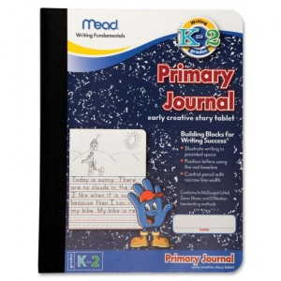
- 1 set of over-the-ear headphone for personal use with laptops in the classroom (Please label and place in a labeled Ziploc bag)-please get a nice sound proof headphone that will last all year.
- One 8-pack fine tip Expo dry erase markers (black is best)
- 4 large pink erasers
- 24 or more pencils-sharpened
- 1 pencil box-labeled
- 1 pair of scissors
- 1 box of crayola crayons-washable
- 4 glue sticks
- 1 Emer’s Glue
- 2 large box of tissue
- 2 containers of clorox/antibacterial wipes
- 1 roll of paper towels
- girls-bring quart-sized baggies
- boys-bring sandwich-sized baggies
- Pocket folders with prongs-4 yellow, 4 green
NOTICE: THE ITEMS ON THIS LIST WILL BE USED DURING THE REGULAR SCHOOL DAY. THEY MAY BE BROUGHT FROM HOME ON A VOLUNTARY BASIS. OTHERWISE, THEY WILL BE FURNISHED BY THE SCHOOL.”

