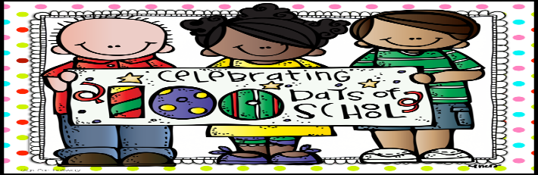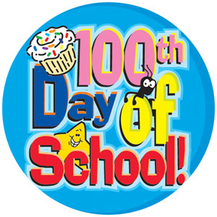
On Friday, January 30th we will be celebrating our 100th day of school. We will be completing all sorts of fun math and language arts activities that day! Attached you will find a zip lock baggie. Please help your child fill this bag with 100 items and bring them to share with our class on Friday, January 30th. Examples could be 100 paperclips, 100 stickers, 100 pennies, etc. The possibilities are endless!
We are also in need of some donations of our 100th day snack mix. If you are able, please have your child bring in ONE of the following items to share with our class. You may also donate $2 if you wish so that we can purchase items-but please do so before Thursday, January 29th.
Teddy Grahams Raisins Large M & M’s bag Pretzel Sticks Fruit Loops
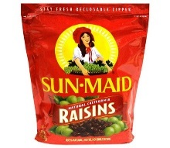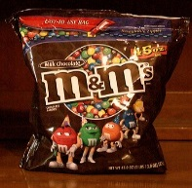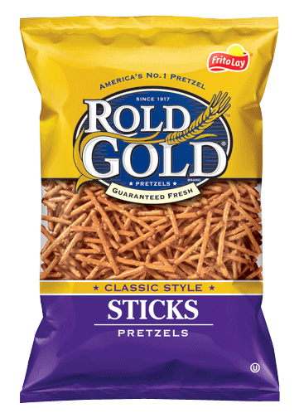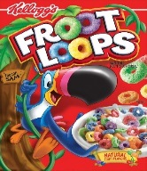
Chocolate Chips Mini Marshmallows Cheerios Goldfish Popped Popcorn
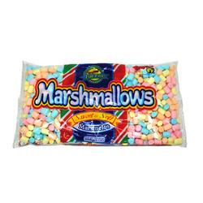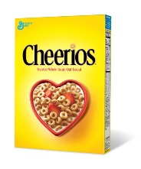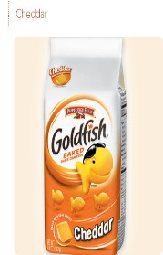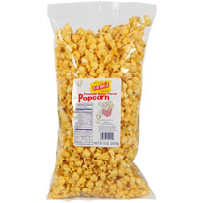
As always, if you have any questions or concerns please feel free to email me. Thank you again for your continued support!
***********************************************************************************************

Please sign, cut and return to school so that your child can participate in the 100th day activities including the above food items, smarties, and suckers.
Student’s Name: ________________________________________________________________
Parent’s Signature: ______________________________________________________________
Restrictions if any: ______________________________________________________________

I give my child permission to participate in all 100th day activities.
I do not give my child permission to participate in the 100th day activities.

