**.**

There are 2 gray bunnies. Another bunny came. Now there are 3 bunnies.

**Grade 1 • Chapter 1** Addition Concepts

**3**

How many strawberries in all? strawberries

**3.**

How many bananas altogether? bananas

**2.**

How many apples in all? apples

**Tell a number story. Use**

**Write how many.**

**1.**

*Addition Stories*

**Reteach**

**Lesson 1**

Name

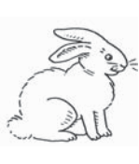

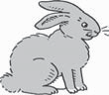

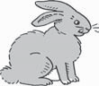

003e_CCSS_C01_RT_116213.tif

003d_CCSS_C01_RT_116213.tif

003b_CCSS_C01_RT_116213.tif

003a_CCSS_C01_RT_116213.tif

003c_CCSS_C01_RT_116213.tif

003c_CCSS_C01_RT_116213.tif

003c_CCSS_C01_RT_116213.tif

003c_CCSS_C01_RT_116213.tif

003c_CCSS_C01_RT_116213.tif

003c_CCSS_C01_RT_116213.tif