The monkey has 2 bananas. He sees 3 more bananas. How many bananas in all?

**Step 4** Count the cubes. Do they match the

**Check** number of bananas in the picture?

**Step 3 Write a number sentence.**

**Solve**  + = bananas

**Step 2 What can I do?**

**Plan** I can the number of bananas.

**Step 1 What do I know?**

He sees more bananas.

**What do I need to find?**

I need to find .

**Grade 1 • Chapter 1** Addition Concepts

**8**

The monkey has bananas.

**Understand**

*Problem Solving*

*STRATEGY: Write a Number Sentence*

**You can add by writing a number sentence.**

Use cubes to show the number story.

**Reteach (1)**

**Lesson 6**

Name

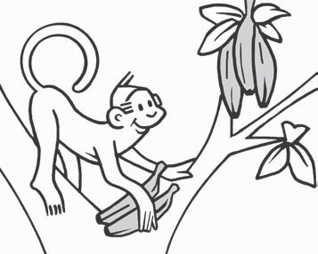

**to show a number story.**

**Grade 1 • Chapter 1** Addition Concepts

**9**

=

+

3 ducks swim.

2 more ducks join

them. How many ducks are swimming?

ducks

**3.**

=

+

4 lions roar.

2 more lions roar. How many lions are roaring?

lions

**2.**

=

+

2 dogs bark.

1 more dog joins

them. How many dogs are barking?

dogs

**1.**

**Find how many in all.**

**Use**

*Problem Solving*

*STRATEGY: Write a Number Sentence*

**Reteach (2)**

**Lesson 6**

Name





































































