**4.** Which object has the faces shown?

**F. G. H. I.**

**3.** Which shape has 1 face and 1 vertex?

**A. B. C.**

**D.**

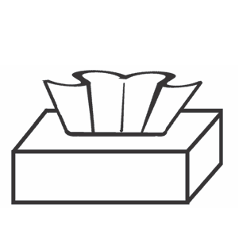

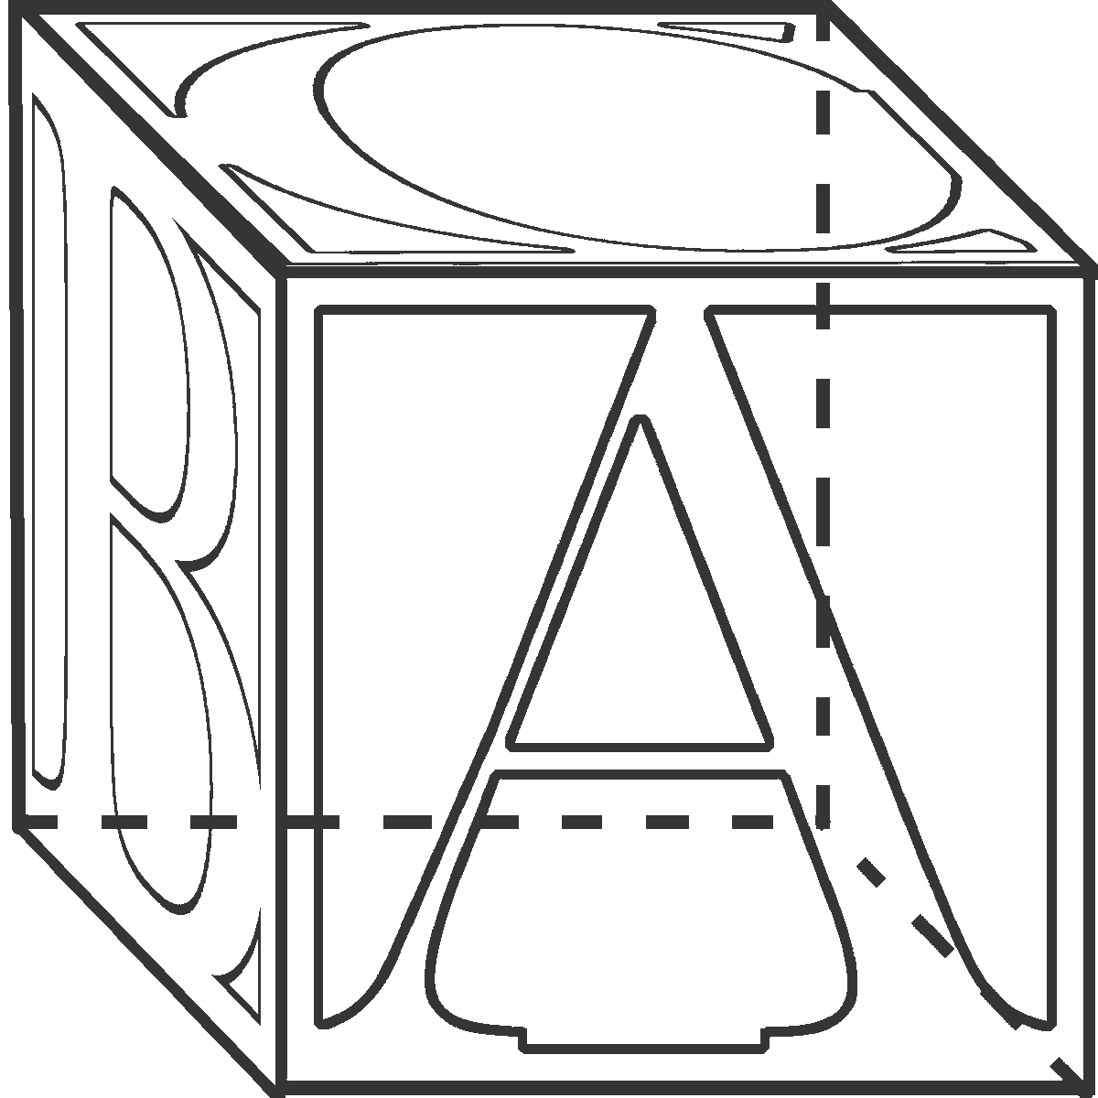

**2.** What is the name of

this shape?

**F.** cube

**G.** cylinder

**H.** cone

**I.** rectangular prism

**1.** What is the name of

this shape?

**A.** cube

**B.** cylinder

**C.** rectangular prism

**D.** cone

**Grade 1 • Chapter 10** Three-Dimensional Shapes

**247**

**Circle the correct answer.**

**Chapter Test, Form 2A**

Name



**8.** Circle the shape of the faces of this object.

**7.** Circle the names of the shapes used to make

this composite shape.

cone cylinder cube

**5.** Circle the name of this

three-dimensional shape.

cube

rectangular prism

**6.** Write the number of

faces and vertices.

faces

vertices

**Grade 1 • Chapter 10** Three-Dimensional Shapes

**248**

*(continued)*

**Chapter Test, Form 2A**

Name