Creating a Board Game Based On Your Fairy Tale, Folk Tale, or Mythological book!
(100 points)

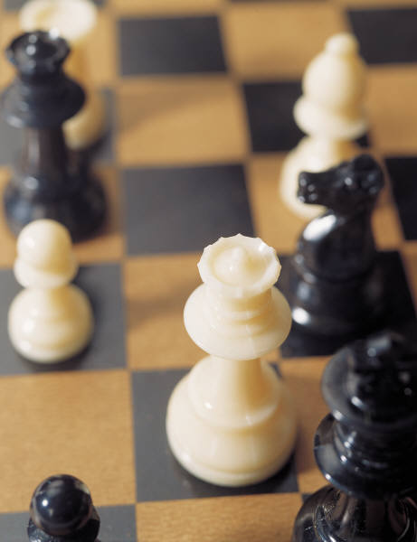

1-Instructions for Play: ______/25
This part of the assignment requires you to describe the following parts of the game. Use these elements as headings, and provide detailed and specific information for each one (look at the instruction sheet that comes with any board game for an example)—

-Number of Players
-Equipment Needed/Description of special parts/equipment/cards, etc.
-Object of the Game
-How to Play/rules of the game
-Duration/Length of game

2-Game Board:________/25
On the file folder provided, you should create a gameboard that relates to the book you read.
The gameboard should be neatly organized and drawn, it should include color, and should be easy to understand.

3-Content of Game:______/25
Game contains adequate & accurate information pertaining to your book.
Provides a solid summary, pictures of scenes from the book, and descriptions of characters. Create at least two pieces. Create cards that take the players through the book.

4-Play/Evaluation Other Groups’ Games: ______/25
Games will be evaluated on:
-Enjoyment
-Clarity of Rules/Instructions
-Inclusion of summary, characters, neatness, and setting.
-All pieces of the game included.

Total Score=_________/100

This project is due November 22..

NO LATE PROJECTS WILL BE ACCEPTED…

