Earth Systems Standard 4-Objective 2

Multiple Choice

a1. Which property of water allows substances spilled on the soil to be carried into underground water supplies? The ability of water to

A. freeze
B. remain a liquid
C. have strong surface tension
D. dissolve many substances

a2. What property of water allows it to form drops?

- adhesion
- precipitation
- cohesion
- condensation

a3. An oil spill at sea often damages birds and sea mammals but fish are relatively unaffected. What properties of water and oil are responsible for this situation?

A. oil is darker in color and has a stronger odor
B. oil is less dense than water and floats on the surface
C. water is harmless to sea life, oil is a poison to most things
D. water floats when it freezes, oil sinks when frozen

a4. Why is water easily polluted?

A. There is more water than anything else.
B. It is found in the air and on land
C. Many substances dissolve in it.
D. It is a substance with high density.

a5. Which property makes water unusual?

- it is less dense as a solid
- it is transparent as a liquid
- it forms a gas at room temperature
- it cannot change from a solid to a gas

Use this information to answer the next three questions.

Students placed hay in pond water in a jar and let it sit for one week. Microorganisms hatch in the water and eat the hay. The students looked at a sample under the microscope every other day for a week. Their results are below:

Day | Microorganisms | Other observations
1 | Some small, fast-swimming microorganisms.  Something wiggling in the background. | Some scum is developing on the top surface
3 | Many more microorganisms than day 1 and two new kinds. One is a paramecium and it is much larger than the others. It swims around. The other is a vorticella that opens and shuts every now and then. | The water is cloudy and thick looking. The hay is starting to disappear.
5 | Fewer small organisms, many paramecium. | It smells awful! The water is turning dark.
7 | No organisms were found. | Extremely bad smell, water is black, hay looks rotten.

b6. What biotic factors influenced the increase in numbers of microorganisms in day 3?

A. the size of the jar
B. the color of the water
C. the exposure to air
D. the amount of food

b7. What is the most likely role the paramecium and vorticella played in the decline of the smaller microorganisms? The paramecium may have

A. produced food for them.
B. taken water from them.
C. eaten them.
D. turned the water dark.

b8. Which best explains the dark color and bad smell in this experiment? The smell and color were caused by

A. wastes from microorganisms and decomposing hay.
B. the pond water turning to swamp water.
C. the cool temperatures of the room preserving the hay.
D. photosynthesis of the algae and other plants that started to grow.

c9. What effect does building a dam on a river have on abiotic factors in the environment?

A. the birds lose nests.
B. the water warms up.
C. the types of fish change.
D. the rocks dry out.

The following data was collected from three mountain streams:

Water Test and Recommended Maximum Values (µg/L) | Stream 1 | Stream 2 | Stream 3
Benzene 2.2 | 2.1 | .02 | 1.5
Cyanide 140 | 220 | 78 | 99
Manganese 50 | 544 | 24 | 66
pH 5 – 9 | 4 | 7 | 6
Selenium 170 | 310 | 45 | 87

c10. Which sample contains the most polluted sample of water?

- Stream 1
- Stream 2
- Stream 3
- They are equally polluted.

c11. What conditions might reduce pH and add heavy metals to stream water?

- agriculture
- sewage
- forests
- mining

c12. Which solution is the most environmentally friendly way to clean the polluted streams?

- build a water treatment plant to clean the water
- find the source of pollution and require it to stop
- allow the water to flow to a lake and let the pollutants settle out
- add chemicals to the stream to clean out the polluting chemicals

Little Cottonwood Creek flows out of the Wasatch Mountains into the Salt Lake Valley. These graphs compare stream flow levels and water depth from a well in the Salt Lake Valley. Use them to answer the next three questions.
Well Water Level
Stream Flow

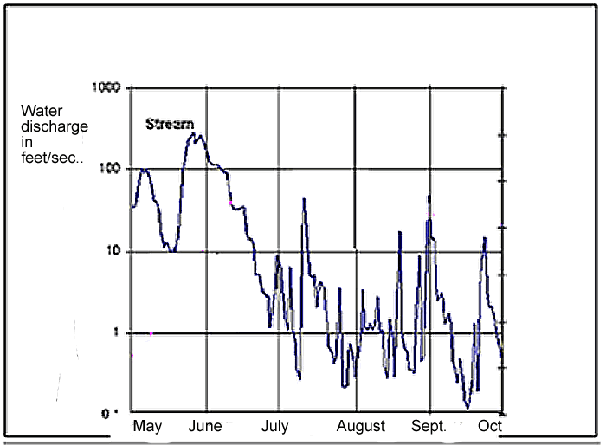
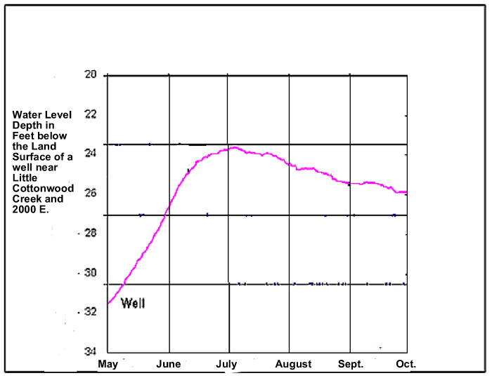

d13. Which month had the highest stream flow?

A. May, the snow was melting in the mountains
B. June, the rainfall and melt water are combined.
C. July, the stream empties from mountain lakes in summer
D. September, the fall rain will fill the stream

d14. How do the stream water level and the well water level appear to be related?

A. low stream flow raises the water in the wells
B. high stream volume in the spring raises the well levels
C. stream flow appears to be unrelated the level of water in the wells.
D. the more water there is in the stream, the less water there is in the well.

d15. What other factors determine how much water is in the well besides stream flow?

A. How much water people are using.
B. The types of pollution in the wells.
C. The weather in the winter.
D. Whether there are nearby lakes.

d16. How does the salt content of sea water affect its’ usefulness to people? The salt

A. makes it valuable for farming and aquariums.
B. makes it as useful as freshwater, just different.
C. reduces the number of ways people can use it.
D. makes it impossible for abiotic factors to survive.

d17. Communities in Utah have choices when additional water is needed for urban needs. Which of the following has NOT been used?

- building a new dam and reservoir
- building a pipeline to bring water from somewhere else
- drilling a new well
- altering rain patterns

d18. What is the least expensive way for communities to deal with water shortages?

A. build a dam to store more water
B. find more water
C. clean their dirty water
D. conserve water

d19. Which use requires the most water?

- farming
- cooking
- lawn watering
- showering

d20. The Jordan River has been straightened and its banks protected to provide flood control. Birds and wildlife prefer wandering rivers because they provide wetlands and slow moving water. How will communities along the river decide how to manage this river?

- The U.S. federal government will decide after doing a study.
- The people with buildings next to the river will decide what is best for them.
- Community and state leaders will study the issues and hold public meetings.
- Environmentalists will meet and decide what is best for the birds.

Essay

1. Water is scarce in the Western United States and its’ use is closely monitored. If a period of drought was to occur and people had to use less water, what are two ways people could use significantly less water? Tell why you think each is a good way to conserve.

2. A community in South Jordan is being planned. A known quantity of water will be available to the community. What are three things the city planners should determine when planning the distribution of water in this area?

Key:

- D
- A
- B
- C
- A
- D
- C
- A
- B
- A
- D
- B
- B
- B
- A
- C
- D
- D
- A
- C

