Earth Science Standard 4-Objective 3

Multiple Choice

a1. What was the original surface of Earth 4.6 billion years ago?

- water
- solid land
- molten rock
- a thick atmosphere

a2. How did early volcanoes affect Earth’s atmosphere?

- they warmed it
- they added gasses
- they drove it into space
- they moved it

a3. What were the two sources of water that created Earth’s oceans?

- Outgassing by volcanoes, ice from comets
- Water from formation, condensation of solar wind
- Melting of glacial ice, evaporation from lakes
- Gases from other planets, gravitational attraction

b4. One group of marine shellfish lives near a coastline by the mouth of a river. Another species of shellfish lives further down the coast. They are never found together. Why?

A. They cannot find food when they are near to each other.
B. The mussels near the river are avoiding people.
C. They do not “know” the other species exists.
D. They prefer different levels of salinity

b5. What do organisms living in the inter-tidal zone (area of land between low and high tides) have in common?

A. they eat the same things
B. they are the same size
C. they have few predators
D. they can survive out of water
b6. Fish living deep beneath the oceans’ surface are rarely or never displayed at seawater aquariums. Why?

A. They are fast swimmers and hard to catch
B. The types of food they need are not available at aquariums
C. They have adapted to intense pressures of the deep
D. Aquariums do not think people will pay to see them.

An oceanographer collected data on the physical properties of the sea in several locations. Then the number of sea snails were counted and averaged in the same locations. Use the following data to answer the next four questions:

Location | Temperature  (degrees C) | Salinity  (parts per thousand) | Depth  (meters) | Average number of snails
Site 1 | 15 | 31 | 22 | 56
Site 2 | 22 | 31 | 7 | 31
Site 3 | 16 | 30 | 17 | 49

b7. Which physical properties do sea snails appear to prefer?

A. Colder, deeper water
B. Colder, shallower water
C. Warmer, deeper water
D. Warmer, shallower water

b8. What relationship appears between depth and temperature?

A. no apparent relationship exists
B. deeper waters are warmer
C. deeper waters are cooler
D. deeper waters lose heat more rapidly

b9. Which factor shows no clear relationship to snail populations in this data?

A. temperature
B. salinity
C. depth
D. snail populations

b10. Why were the snail populations counted several times and averaged?

A. to increase the accuracy of the results
B. to make sure none were missed
C. to have more opportunities to see the snails
D. to see if the snails are moving from one place to another
Use the cross section of an ocean floor to answer the following question:
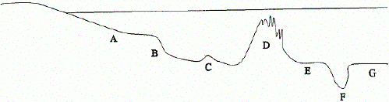

b11. Organisms living at "G" would be adapted to which kind of conditions?

A. high amounts of light, low pressures
B. high amounts of light, high pressures
C. no light, low pressure
D. no light, high pressure

c12. A student places a drop of freshwater on a glass slide and a drop of seawater on a glass slide. The slides are gently heated so that the water evaporates. How will the slides compare to one another?

- the slides will now look the same
- the seawater slide will have a salty deposit, freshwater will have no trace
- the freshwater slide will have a white ring, seawater will have no trace
- the seawater slide will have a larger salty deposit than the freshwater
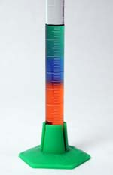
c13. A student is given three beakers of colored water that have different levels of salinity. The student carefully adds several drops of each to a cylinder. The results are shown in the picture Which water has the highest salt content?

- Green (top)
- Blue (middle)
- Red (bottom)
- they have the same salt content

c14. 50 mL of seawater and 50 mL of freshwater are massed on a balance. How will their masses compare?

- seawater will have a greater mass
- freshwater will have a greater mass
- seawater will have a lesser mass
- freshwater will not compare to seawater.

c15. Why are icebergs made of freshwater?

- seawater does not freeze
- freshwater floats when it freezes
- seawater requires a lower temperature to freeze
- freshwater has trapped air bubbles that allow freezing to occur.

d16. Which of the following is NOT a physical property of oceans?

A. waves
B. ocean currents
C. tides
D. algae growth

d17. What is the main source of energy for the ocean?

A. the sun
B. Earth’s core
C. radioactive rocks
D. fossil fuels

d18. What important function do currents and areas of upwelling provide for living things in the sea?

A. Recycles the ocean water through evaporation and precipitation
B. Brings nutrients up from deeper water for use by organisms
C. Mixes land and sea organisms to broaden the food web
D. Allows Earth to have weather and climate changes

d19. Which of the following most accurately models the production of waves in the ocean?

A. shaking a dish of water from side to side
B. shining a light on a dish of water then turning it off.
C. stirring a dish of water in a circle
D. blowing across the surface of a dish of water.

Students wonder if waves are caused by wind. To test this hypothesis they go to a beach and measure the wind speed, wind direction and wave height for a week. The table below shows the results. Use it to answer the next three questions.

Day | Wind Speed  (mph) | Wind Direction | Average Wave Height  (meters)
1 | 8 | S | .4
2 | 5 | S | 1.0
3 | 16 | SE | 1.8
4 | 22 | S | 2.4
5 | 13 | SW | 1.2
6 | 9 | NW | .3
7 | 6 | N | .5

d20. Does wave height appear to be related to wind speed or direction?

A. Direction, the highest waves occurred during a SE wind.
B. Direction, the lowest waves occurred during a N wind.
C. Wind speed, the highest waves were during the strongest winds.
D. Wind speed, the highest waves were during the lowest winds.

d21. What conclusion best summarizes this experiment?

A. Wave height is related to the direction from which the wind blows.
B. Wave height depends on many factors but not wind speed or direction.
C. Wave height is determined by the speed of the winds.
D. Waves move for no testable reason.

d22. Which of the following hypothesis would be a logical follow-up to this experiment?

A. If waves are not influenced by direction, then nothing else will affect them.
B. If winds blow over long distance, then wave height will be greater.
C. If waves are present, then they will be higher.
D. If the beach is shaped like an “L”, then waves will be smaller.

d23. What is the main cause of Earth’s surface currents?

- gravity
- density
- prevailing winds
- high pressure areas

d24. Why does the wind almost always blow at a beach?

- air and water reflect sunlight differently
- air moves from high places to low places
- air flow is altered by gravity over the land
- air currents from land sweep out into the sea

d25. What causes tides?

- the action of wind and currents on the water
- the rising and sinking of beach fronts
- the movement of faults in ocean floors
- the pull of gravity from the moon and sun

A clean up project on a beach in Texas resulted in the following data. Use it to answer the next two questions:
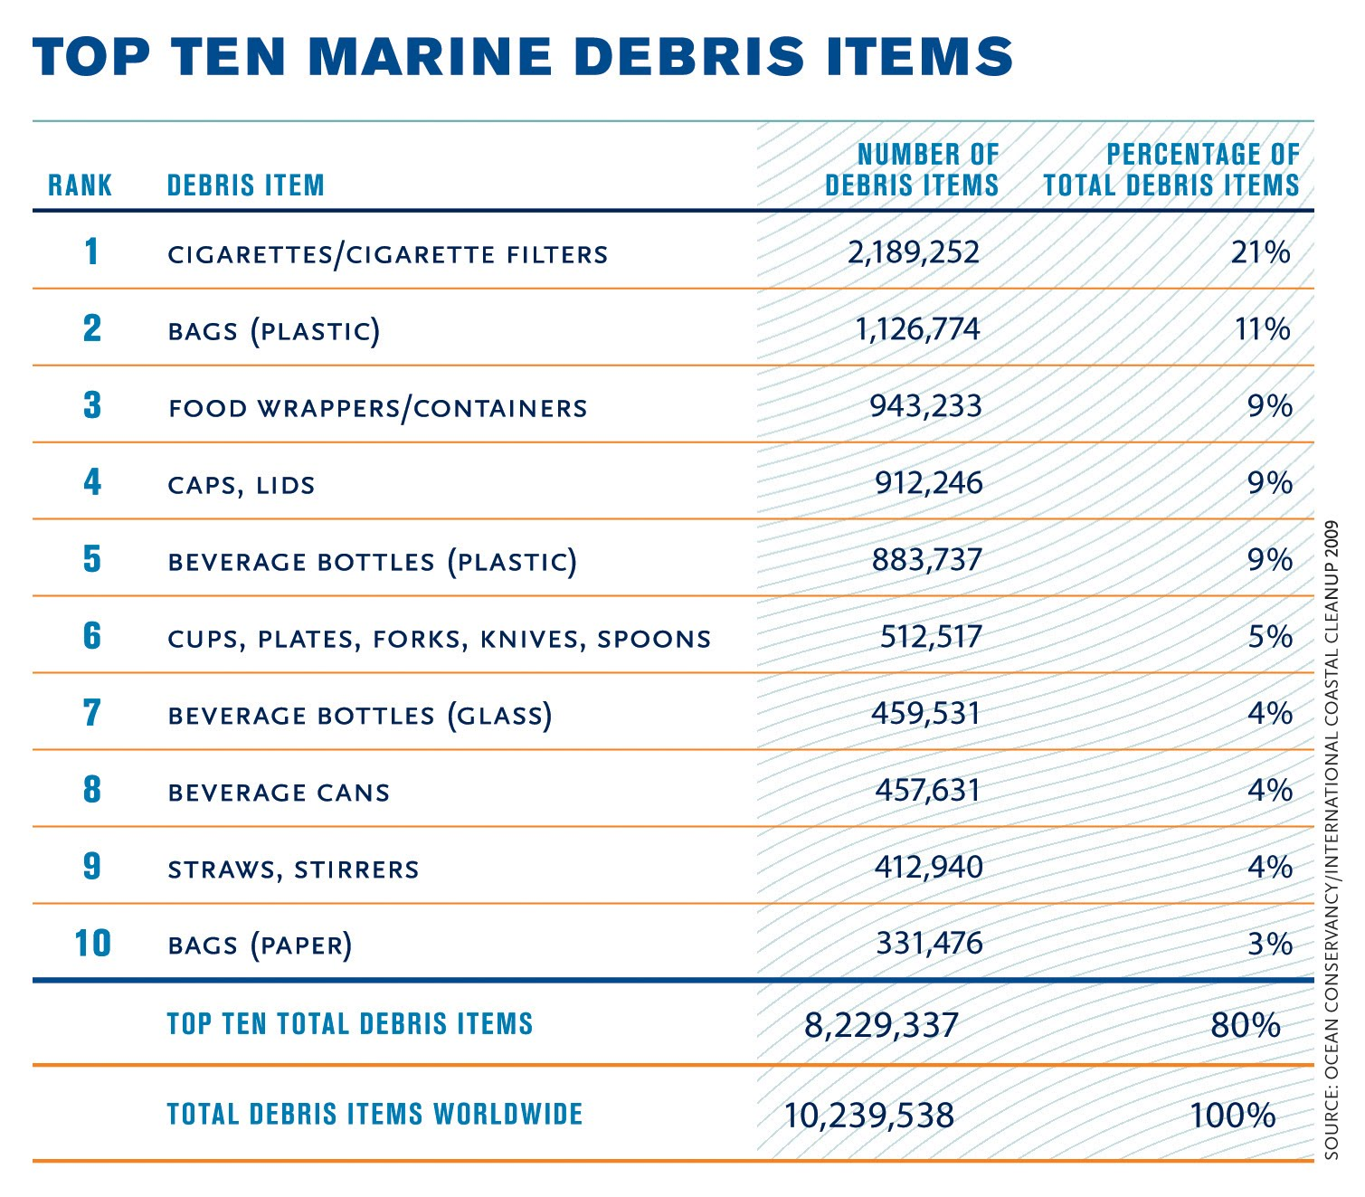

e26. How did these items get into the ocean?

- They were not disposed of properly
- Cites legally dumped of them in the ocean
- The items blew in during a wind storm
- They were washed in from other countries

e27. Which type of trash is most abundant?

- Manufacturing wastes
- Farming and animal wastes
- Discarded paper and food wastes
- Food and dining plastic products

e28. Which group of organisms is most susceptible to sediments that sink into the shoreline?

- predatory fish; they have poor vision
- shellfish; they are attached to their substrate.
- sea mammals; they come to the surface to breathe
- schooling fish; they move in large groups.

e29. What must occur to maintain economic feasibility of fishing in the worlds’ oceans?

- increased fish catches
- sustainable harvesting
- fishing must cease
- increased government support

e30. Why will human caused changes to the ocean be hard to reverse?

- The ocean is so large
- The ocean is irreversible
- The ocean has too much life
- The ocean water does not change physically

Essay

- Propose a law you would enact (if you were president) concerning the oceans. Tell why you think it is important.

2. Describe an experiment you would like to do if you could spend a day on the ocean.

Answers:
- C
- B
- A
- D
- D
- C
- A
- C
- B
- A
- D
- B
- C
- A
- C
- D
- A
- B
- D
- C
- C
- B
- C
- A
- D
- A
- D
- B
- B
- A

