Earth Science Standard 5, Objective 1

Multiple Choice.

a1. “Energy flows and matter cycles” is a way to think about the movement of energy and matter on Earth. Why is energy different than matter?

- Energy is renewable and recyclable.
- Energy is indestructible and cannot be lost.
- Energy is lost over time and must be replaced.
- Energy moves in cycles from one reservoir to another.

a2. What type of matter and energy make up the geosphere?

- Air; solar radiation, heat, movement
- Solid rock; heat, radioactivity, gravity
- Water; solar radiation, heat, movement
- Living things; solar radiation, heat, movement

a3. How does a volcano illustrate matter cycling and energy flowing?

- Lava is cycling from the geosphere back into the hydrosphere.
- Lava radiated by sunlight is melting into a new type of material.
- Lava heated by radioactivity is moving rock through the rock cycle.
- Lava left behind from the formation of Earth is cooling underground.

a4. Which is an example the atmosphere interacting with the geosphere?

A. rain washes loose sand into a lake
B. clouds block light from the forests.
C. animals add carbon dioxide to the air
D. water provides oxygen for animals to breathe

a5. A volcano erupts and spread ash into the sky. Which question could be answered by a scientist concerning the effects of the volcano on the atmosphere?

A. How many cubic tons of rock are involved in the eruption?
B. How has the ash affected the light passing through the air?
C. Were any living things hurt by the volcanic eruption?
D. Will the eruption happen again any time soon?

a6. Which of the following is an example of the biosphere interacting with the atmosphere?

A. a human breathing in and out
B. a volcano adding ash to the air
C. a rainstorm filling a stream over its banks
D. a plant root cracking a rock in two.

b7. What is meant when Earth’s systems are said to be “dynamic”?

- they are all the same type
- they are slow moving
- they cannot be measured
- they are constantly changing

b8. How does a flood affect the biosphere in the area?

- Most plants and animals must migrate or die.
- The soil fills with water and becomes saturated.
- The rise in relative humidity increases the cloud cover.
- Most of the species benefit from the increased amount of water.

b9. Which Earth system is unchanging?

- geosphere; rocks and land are stationary
- atmosphere; the air is always present
- hydrosphere; water is found in the same locations
- none; all systems change from natural and human causes.

c10. How do imaging satellites in space increase our understanding of changes to Earth systems?

- They document changes in Earth’s orbit.
- They measure the thickness of Earth’s layers.
- They predict the location of the next earthquake.
- They provide accurate photographs of vegetation.

c11. Very accurate measurements are now made to document sea floor spreading. What technology has allowed this to happen?

- global positioning satellites (GPS)
- international space station (ISS)
- international system of measurements (ISM)
- computer-based current buoys (CCB)

c12. How did the development of echo sounding radar devices allow oceanographers to learn more about the oceans?

- They could count the number of sea mammals.
- They could measure minerals in seawater anywhere in the sea.
- They could measure the shape of the sea floor.
- They could record water temperatures at different depths.

c13. Our scientific understanding of the different layers of Earth is based on data from which technology?

- Doppler radar
- global positioning systems
- imaging satellites
- seismic sensors

Students read a newspaper article about particulate pollution falling on snowpack. The researcher is trying to find out if the snow melts differently when it has this darkened surface. The students design an experiment to test this question. Use this information for the next 5 questions.

d14. Which conditions should the control snow patch have?

- it should have an unpolluted surface.
- It should have the same surface as the test surface.
- It should be thicker than the test patches and cleaner.
- It should be thinner than the test patches and have a darken surface.

d15. Which hypothesis describes a logical test?

- If we darken the snow surface, then the melting temperature will change.
- If we darken the snow surface, then the amount of sunlight will change.
- If we darken the snow surface, then the snow thickness will change.
- If we darken the snow surface, then the snow will melt faster.

d16. How will the results be measured?

- color of the melt water
- melting temperature of the snow
- time it takes the snow to melt
- amount of radiation striking the snow

The students collected the following data on their snow experiment:

Amount of Snow Remaining
Snow patch | After 2 hrs | After 4 hrs | After 6 hrs | After 8 hrs
Control 1 | 90% | 80 % | 75% | 70%
Control 2 | 88% | 82 % | 76% | 71%
Control 3 | 90% | 81% | 74% | 70%
Test 1 | 85% | 76% | 54% | 40%
Test 2 | 86% | 75% | 55% | 41%
Test 3 | 84% | 76% | 55% | 40%

d17. What additional analysis should the students perform with their data?

- line of best fit
- averages and a graph
- box and whisker plots
- mean and median for each column

d18. Which conclusion best summarizes their data?

- Particulate pollution increases the rate which snow melts.
- Particulate pollution decreases the rate at which snow melts.
- Particulate pollution is found in many areas of the United States.
- Particulate pollution from the air pollutes the meltwater from snow.

e19. Why do scientists create models called feedback loops?

- to store and analyze data for future use
- to design experiments showing Earth changes
- to inform the public about Earth’s interacting systems
- To solve the more simple and straight forward types of questions

e20. A feedback loop that results in an increase in the original action is referred to as a:

- Negative feedback loop
- Positive feedback loop
- Neutral feedback loop
- Normal feedback loop

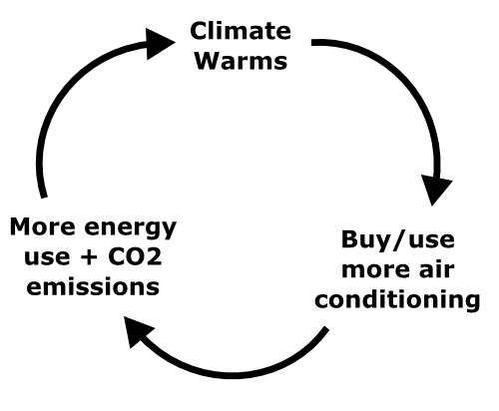
e21. What type of feedback loop is this an example of:

- negative
- positive
- neutral
- normal

e22. Why are scientists concerned that climate change involves many positive feedback loops?

- A positive loop will never stop moving.
- Once the loop starts, it is difficult to stop
- A negative loop is better for the environment.
- People may view climate change as a good thing.

Essay:

- Explain why new scientific understandings often accompany the use of new technology.

- Draw a positive feedback loop for an Earth system:

Key:

- C
- B
- C
- A
- B
- A
- D
- A
- D
- D
- A
- C
- D
- A
- D
- C
- B
- A
- C
- B
- B
- B

