Earth Science Standard V, Objective 2

Multiple Choice.

a1. The United States enjoys a high standard of living when compared to most other countries of the world. What is one important reason?

- The United States is larger than other countries.
- The United States has an abundance of natural resources.
- Other countries have developed their natural resources poorly.
- Other countries have sent their natural resources to the United States.

Use this map to answer the next two questions:

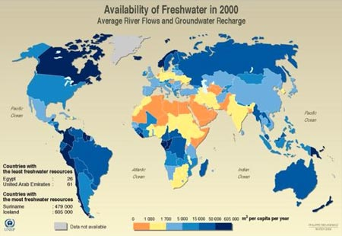
www.climate.org
a2. In general, which countries already face water shortages?

- South American countries
- South Africa, the Middle East, India
- Australia, Oceania
- United States and Canada

a3. Which best describes the conditions found in the United States?

- The U.S. should begin water rationing soon, we are running out.
- The U.S. should develop water resources carefully; we have none to waste.
- The U.S. should not worry about water resources; we have plenty of water.
- The U.S. should consider sending more water to other countries that may need it.

Use this graph of global (human) population and cereal (grain) production to answer the next question:

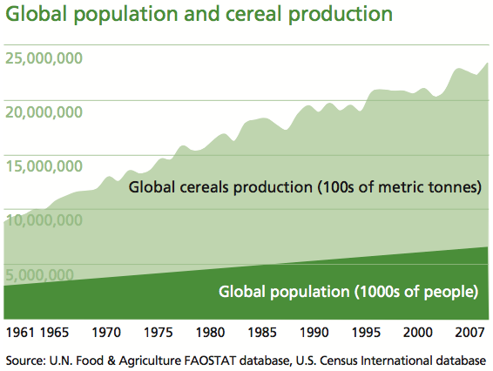

b4. Which statement best summarizes the data found on the graph?

- Cereal production is keeping up with human population growth.
- Cereal production is responsible for the growth of human populations.
- Cereal production must increase for all countries to feed their populations.
- Cereal production increases have allowed the population to have enough food.

Use the diagram on the right for the next two questions.

b5. How does dependence on local forests Gathering Wood for Cooking Fuel
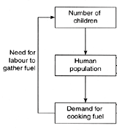
for cooking fuel affect population?

- Population is unaffected
- Population decreases
- Population increases
- Population improves

b6. What effect does gathering wood for fuel
have on local forests?

- The forests disappear
- The forests grow faster
- The forests maintain their size
- The forests change into swamps
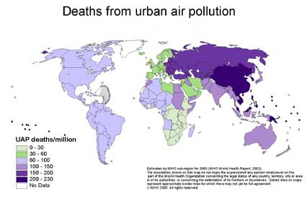

b7. Which countries face the most severe health hazard related to air pollution?

- Brazil, Canada
- China, Russia
- South Africa, Australia
- United States, Argentina

b8. What conditions are responsible for this pattern?

- Weather patterns that create storm systems, use of fossil fuels in manufacturing.
- Warmer oceanic currents on nearby land masses, abundance of factories rural areas.
- Rapid population growth in urban areas, lack of government pollution controls.
- Atmosphere near the equator is warmed excessively by sunlight, trapping pollutants.

c9. How will the development of alternative energy sources affect Earth systems?

- land and air pollution will be reduced
- people will have fewer choices of fuels to power their cars
- the geosphere and biosphere will have less affect on one another
- the alternative sources will pollute water and create shortages

c10. What effect does the building of a dam and reservoir have on a river valley?

- the river becomes a natural lake
- the river valley eventually recovers
- the towns upstream face water shortages
- the natural ecosystem is destroyed
c11. What must a mining company do to protect the environment from potential damage?

- Raise herds of deer to replace any species that are displaced.
- Build smelters and processing plants on flat ground, not hillsides.
- Prevent mining wastes from entering water sources and the air.
- Allow only nitrogen and sulfur compounds to be released into the air.

Use this information to answer the next three questions:
The United States Geological Survey (USGS) has a long history of providing data on water quality and quantity in the U.S. Perhaps best known is the USGS data on stream flow, which is collected through a national network of more than 7,000 stream gages as part of the USGS National Water Information System. This valuable data is immediately available to the public. The USGS Water Census will allow the analysis of trends in surface water availability and develop methods for estimating stream flow at unmeasured locations. From: http://waterdata.usgs.gov/nwis

d12. What kind of data are scientists collecting with the stream gages?

- The quality of the water in a stream.
- The depth of the water in a stream.
- The temperature of water in a stream.
- The amount of water flowing in a stream.

d13. Why do scientists collect this data?

- To make sure enough water is available for everyone.
- To increase the amount of water available to farmers.
- To help water managers make decisions on water use.
- To allow streams and rivers to flow in natural patterns.

d14. What is the role of USGS scientists?

- to collect and report data accurately
- to decide who gets the water in the streams
- to report to the public on correct water uses
- to tell government agencies what to do with water.

e15. A mining company wants to expand a mine near a town. What question should the people of the town ask the company?

- How long will the expansion take?
- Who will be in charge of the expansion?
- How much money will the expansion cost?
- How will water and air quality be protected?

e16. A politician claims that a scientific study on climate change is incorrect. What is the difference between the politician and the scientists’ viewpoints?

- The scientists have collected climate data and analyzed it.
- The scientists know more than anyone else.
- The politician has collected climate data and analyzed it.
- The politician knows more than anyone else.

e17. How should an average citizen decide how to vote on issues of air, water, soil or ecosystems?

- Talk to your neighbors and see what they think.
- Read scientifically-based information from reliable sources.
- Follow a leader that you like and vote the way they tell you to.
- Listen to radio talk shows that are popular and controversial.

Essay:

- In what ways do humans rely on Earth resources to stay alive?

- How can understanding Earth science help people understand how to use natural resources?

Key:

- B
- D
- B
- A
- C
- A
- B
- C
- A
- D
- C
- D
- C
- A
- D
- A
- B

